

CSIR-Central Mechanical Engineering Research Institute, Durgapur
Internship Report

Name: Soumyadeep Dey
Specialization: B-Tech in Mechanical Engineering Roll No.: 23ME8009
Institute: National Institute of Technology, Durgapur
Internship Title: Friction Modelling of a 6-DOF Robotic Arm using Physics Based or Machine Learning Approaches
Duration: 20th May, 2026 – 2nd July, 2026
Organization: Human Centred Robotics and Cybernetics
Supervisor: Dr. Soumen Sen

ACKNOWLEDGEMENTS
I would like to express my sincere gratitude to the Director, CSIR-CMERI, for providing the opportunity and necessary facilities to carry out this internship. I am deeply thankful to my supervisor, Dr. Soumen Sen, mentors Dr. Deepak Kr. Yadav, Dr. Sumeet Kr. Yadav, Dr. Som Shukla, and my co-worker Mr. Pradip Saha for their valuable guidance, continuous support, and technical insights throughout this project. I also thank the Department of Mechanical Engineering, NIT Durgapur, for its academic support. Finally, I acknowledge the use of AI tools, including ChatGPT (OpenAI), Claude (Anthropic), and Gemini (Google), for assistance with code development, debugging, and documentation. All generated content was reviewed, validated, modified, and integrated into the final work by the author.
ABSTRACT
Friction is one of the major factors that reduces the positioning accuracy and motion performance of robotic manipulators. In collaborative robots, the presence of harmonic drive gearboxes makes the friction behaviour highly nonlinear and difficult to model accurately. An effective friction model is therefore essential for improving trajectory tracking, reducing control errors, and achieving smooth robotic motion.
This internship focuses on the friction modelling of a 6-DOF Svaya collaborative robotic arm using experimental joint telemetry collected through the robot's API. The recorded data includes joint position, velocity, motor torque, and joint torque. The acquired signals were pre-processed to obtain synchronized kinematic quantities and the corresponding friction torque required for model development.
Three different friction modelling approaches were implemented and compared. The first approach is a Modified Coulomb-Viscous analytical model that combines Coulomb friction and viscous damping using a smooth hyperbolic tangent function with a position-dependent correction term. The second approach is a Deep Neural Network (DNN), which learns the nonlinear relationship between joint position, velocity, and friction torque directly from the experimental data. The third approach is a Physics-Informed Neural Network (PINN), where the analytical friction model is incorporated into the neural network training process to estimate the parameters of the LuGre dynamic friction model while ensuring physical consistency.
The performance of all three approaches was evaluated using experimental data from Joints 1, 2, 3, and 5. Error metrics such as Mean Squared Error (MSE), Root Mean Squared Error (RMSE), and Mean Absolute Error (MAE) were used for comparison. The analytical model provides an interpretable and computationally efficient solution suitable for real-time implementation. The DNN achieves higher prediction accuracy by learning complex nonlinear friction characteristics, while the PINN combines the advantages of physics-based modelling and machine learning to produce physically meaningful and stable parameter estimation.
The work demonstrates that combining analytical models with modern artificial intelligence techniques provides an effective framework for accurate friction modelling and future real-time friction compensation in collaborative robotic manipulators.
TABLE OF CONTENTS
- Introduction
- Literature Review
- Kinematic Modelling & Theoretical Framework
- Implementation & Experimental Setup
- Friction Modelling Approaches
- Results & Discussion
- Conclusion & Future Scope
- References

CHAPTER 1: INTRODUCTION
1.1 Background
Collaborative robots, commonly known as cobots, are increasingly used in manufacturing, healthcare, research laboratories, and service industries because they can safely interact with humans while performing precise tasks. Unlike conventional industrial robots, cobots are designed to operate with high positional accuracy, smooth motion, and reliable force control. Achieving this level of performance requires accurate modelling of the robot dynamics.
One of the major challenges in robotic manipulators is joint friction. Friction originates from bearings, gearboxes, lubrication, seals, and mechanical contacts inside each joint. In robots equipped with harmonic drive gearboxes, friction becomes highly nonlinear and varies with joint velocity, position, loading conditions, and operating environment. If friction is not properly compensated, it can cause tracking errors, stick-slip motion, oscillations, increased energy consumption, and reduced control accuracy.
Traditional analytical friction models are computationally efficient and easy to interpret, but they often fail to capture complex nonlinear friction behaviour. On the other hand, modern machine learning techniques can learn complicated nonlinear relationships directly from experimental data but usually require large datasets and often lack physical interpretability. Physics-Informed Neural Networks (PINNs) provide a promising solution by combining physical knowledge with machine learning, resulting in models that are both accurate and physically consistent.
This internship investigates and compares analytical modelling, deep learning, and physics-informed learning techniques for friction modelling of a 6-DOF robotic manipulator using experimentally collected telemetry data.
1.2 Problem Statement
The friction present inside robotic joints significantly affects the positioning accuracy and dynamic performance of collaborative robots. Existing analytical models are often unable to represent all nonlinear friction characteristics, while purely data-driven approaches may ignore the underlying physical behaviour of the system. Therefore, there is a need for a modelling framework that combines physical understanding with machine learning to accurately estimate friction using only the robot's internal telemetry data without requiring additional external sensors.
1.3 Objectives
The objectives of this internship are:
- To study the kinematic structure and dynamics of the 6-DOF robotic manipulator.
- To collect and preprocess joint telemetry data, including joint position, velocity, motor torque, and joint torque using the Svaya API.
- To estimate the friction torque acting on individual joints using experimentally measured data.
- To develop a Modified Coulomb-Viscous analytical friction model for baseline friction estimation.
- To develop a Deep Neural Network capable of predicting nonlinear friction torque directly from experimental data.
- To develop a Physics-Informed Neural Network for estimating the parameters of the LuGre friction model using physics-based constraints.
- To compare the performance of the three modelling approaches using standard error metrics such as MSE, RMSE, and MAE.
- To identify the most suitable approach for future real-time friction compensation on embedded robotic hardware.

CHAPTER 2: LITERATURE REVIEW
The study of friction in mechanical systems has evolved from empirical static models to dynamic machine-learning frameworks. The literature is broadly categorized into classical analytical models and modern learning architectures.
2.1 Classical Friction Modelling
Early approaches to friction compensation relied on static and dynamic analytical models. Olsson et al. (1997) comprehensively detailed the transition from basic Coulomb and viscous friction models to those capturing complex phenomena like the Stribeck effect and pre-sliding hysteresis. Building upon this, van Geffen (2009) evaluated integrated frameworks, highlighting the Dahl and LuGre models. The LuGre model treats the friction interface as elastic bristles, successfully capturing both rate-dependency and zero-slip displacement. However, parameterizing these models analytically requires highly specialized isolation.
2.2 Neural Networks and Physics-Informed Learning
Recent computational advancements have shifted the paradigm toward machine learning. Luo et al. (2024) demonstrated that using neural networks for robotic joint friction parameter identification yields significantly higher accuracy compared to traditional optimization algorithms like GA or PSO, particularly in noisy industrial environments.
Scaling this to complex hardware, Sorrentino et al. (2024) successfully applied Physics-Informed Neural Networks (PINNs) to high-ratio harmonic drives in humanoid robots, proving that accurate friction identification can be achieved using intrinsic robot state data rather than external torque sensors. Furthermore, Ozmen et al. (2026) established that network-identified friction models (such as LuGre) are highly transferable; networks trained on small, noisy datasets can generalize across dynamic systems, overcoming the limitations of standard robotic simulators.
2.3 Research Gap
While advanced neural models have been validated on specific humanoids or simulated joints, there remains a need to apply these frameworks to commercial industrial cobots using standard API telemetry. This project addresses this gap by utilizing API data from a Svaya cobot to evaluate both a modified analytical physics model and a modern DNN.

CHAPTER 3: KINEMATIC MODELING & THEORETICAL FRAMEWORK
3.1 Kinematic Modelling: Modified DH Parameters
To accurately assess joint torques, the spatial geometry of the robotic arm must be mathematically defined. This project utilizes the Modified Denavit-Hartenberg (Craig's convention) rule. Unlike standard DH parameters, the Modified DH convention attaches the coordinate frame ‘i’ to the axis of joint ‘i’, which is highly preferred in robotics dynamics as it links the coordinate frame directly to the motor driving that joint.
The four Modified DH parameters linking frame (i-1) to frame (i) are:
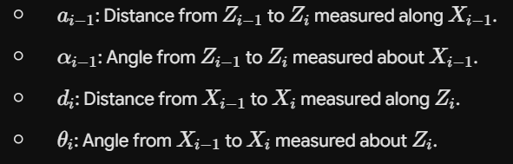

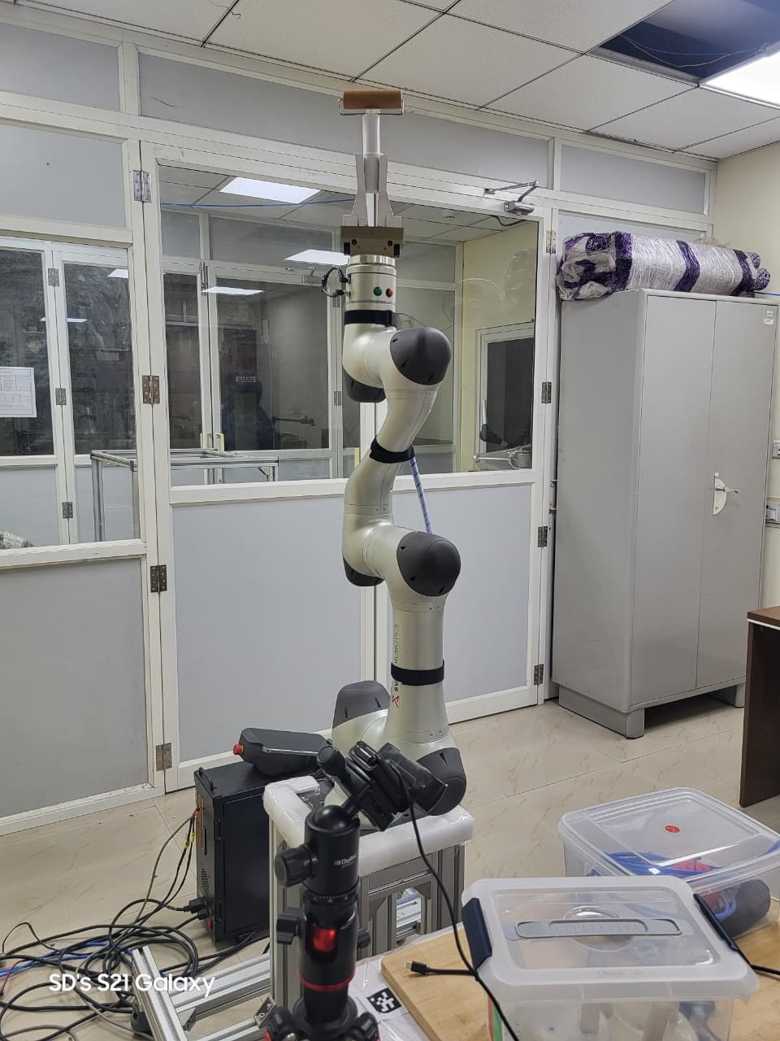

Figure 3.1: Physical architecture of the 6-DOF Collaborative Robotic Manipulator.

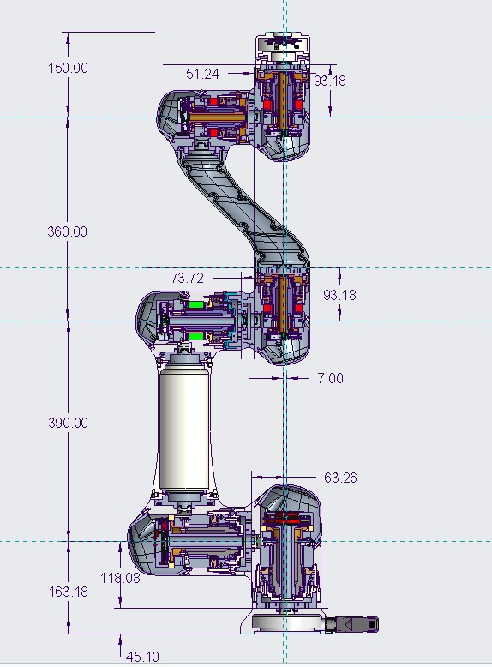

Figure 3.2: Structural dimension variables of the manipulator.

3.2 DH Parameter Table for the Manipulator
Based on the provided structural dimensions, the theoretical Modified DH parameter table is constructed.
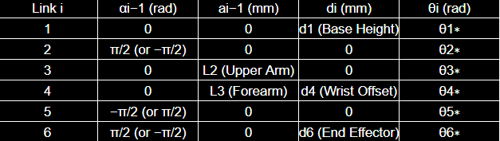

Figure 3.3: Final calculated Modified DH Parameters for the 6-DOF System.

CHAPTER 4: IMPLEMENTATION & EXPERIMENTAL SETUP
4.1 Hardware and Software Environment
- Hardware: 6-DOF Svaya Collaborative Robot.
- Telemetry Interface: Svaya API v2.1.1.
- Computational Stack: Python 3, Pandas (Data processing), Scipy (Analytical optimization), TensorFlow/Keras (DNN architecture).
4.2 Data Acquisition and Telemetry Isolation
During the repetitive motion experimental phase, the API continuously logged a state matrix for the entire manipulator. Because the robot is a highly coupled system, isolating the dynamic behaviour of individual joints is critical. The global dataset was computationally filtered to extract the specific telemetry of the primary load-bearing joints (Joints 1, 2, 3, and 5).
For each targeted joint, the following variables were extracted:
- m_t_i: Motor Torque (N-mm)
- jts_i: Joint Torque (N-mm)
- v_i: Actual Joint Velocity (degree/sec)
- q_i: Actual Joint Position (degree)
4.3 Kinematic State Derivation via Numerical Differentiation
While the API provides instantaneous states, physical friction models require mathematically rigid kinematic derivatives. To ensure accuracy, the true joint velocity and joint acceleration were derived from the time-series position data using a custom Pandas pipeline.
- Time Normalization: String timestamps were converted to datetime objects, and an elapsed time vector in seconds was generated.
- True Velocity & Acceleration: Computed using first-order finite differences over the differential elapsed time:
velocity = delta q / delta t
acceleration = delta v / delta t
This operation enriched the localized datasets, providing time-synchronized arrays of Position, Velocity, Acceleration, and Motor Torque.

CHAPTER 5: FRICTION MODELING APPROACHES
Three distinct modelling architectures were implemented to identify the friction parameters based on the derived telemetry.
5.1 Approach 1: The Modified Coulomb-Viscous Analytical Model
To establish a baseline physical model, a continuous approximation of the Coulomb and Viscous friction was formulated. To avoid the mathematical discontinuity of the standard signum function near zero velocity (which causes computational instability), a hyperbolic tangent function was utilized. Additionally, a position-dependent coupling term was introduced.
The effective velocity and the modelled friction torque are defined as:
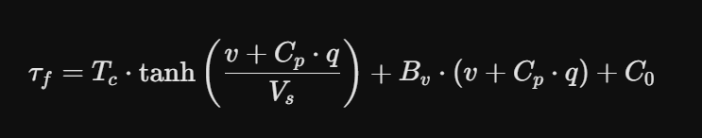Where:
- T_c: Coulomb friction amplitude
- V_s: Stribeck velocity shape factor (Threshold Velocity)
- B_v: Viscous damping coefficient
- C_0: Static offset
- C_p: Position offset
- q: Joint position
- v: Joint velocity
The true friction torque label was derived applying a gear ratio of N = 100: 1
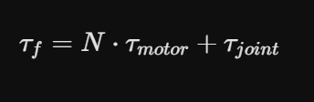
- tau_f: Total friction torque.
- N: Gear reduction ratio.
- tau_motor: Torque generated by the motor.
- tau_joint: Torque acting on the joint (often the external load or link dynamics).
This analytical model was optimized using scipy.optimize.curve_fit to minimize the Mean Squared Error (MSE) across the active joints.

5.2 Approach 2: Deep Neural Network (DNN / Black-Box Model)
To capture higher-order, unmodeled non-linearities (such as temperature-dependent pre-sliding hysteresis and complex gear meshing friction), a purely data-driven Deep Neural Network was constructed.
- Architecture: Multi-Layer Perceptron (MLP) Sequential model in TensorFlow.
- Inputs: Scaled real-time API states (Position q, Velocity v).
- Outputs: Predicted Friction Torque (tau_f).
- Training: The network was trained iteratively on individual joints, utilizing Early Stopping to prevent overfitting on the noisy empirical telemetry.

5.3 Approach 3: Physics Informed Neural Network (PINN Model)
To capture non-linear joint dynamics while ensuring physical consistency, a hybrid PINN architecture was developed using a two-stage regression strategy and custom physics-informed loss constraints.
- Two-Stage Decoupling: Stage 1 uses classical linear regression across high-velocity windows to deterministically isolate macro-dynamics (Coulomb offsets F_c, viscous damping sigma_2). Stage 2 uses these as structural anchors to bound the parameter space, allowing the network to reliably converge on internal dynamic parameters (stiffness sigma_0, damping sigma_1) without hitting local minima or gradient explosions. In stage 1, I used tau_f as target variable and velocity and position as inputs and by least square method I determined the parameters of Viscous + Coulomb friction and taking these equations as true form, in stage 2, I developed a PINN which will predict Lugre Friction Model parameters and in loss function we will give the Viscous + Coulomb true equations with only velocity and positions as unknowns.
- Physics-Informed Regularization: Embeds analytical Coulomb-Viscous steady-state behaviors (dz / dt = 0) into the loss layer to penalize non-physical deviations from the measured friction residual (tau_f_meas = N * tau_motor + tau_joint). This filters out raw telemetry noise and motor vibrations near zero-velocity transitions (v approx 0).
- Optimization & Consistency: Trained via the Adam optimizer using a dual-objective loss function that balances empirical data matching with physical laws. The resulting parameters strictly satisfy thermodynamic principles (positive dissipation: sigma_0, sigma_2 > 0), providing a stable framework for real-time feedforward torque compensation.

CHAPTER 6: RESULTS & DISCUSSION
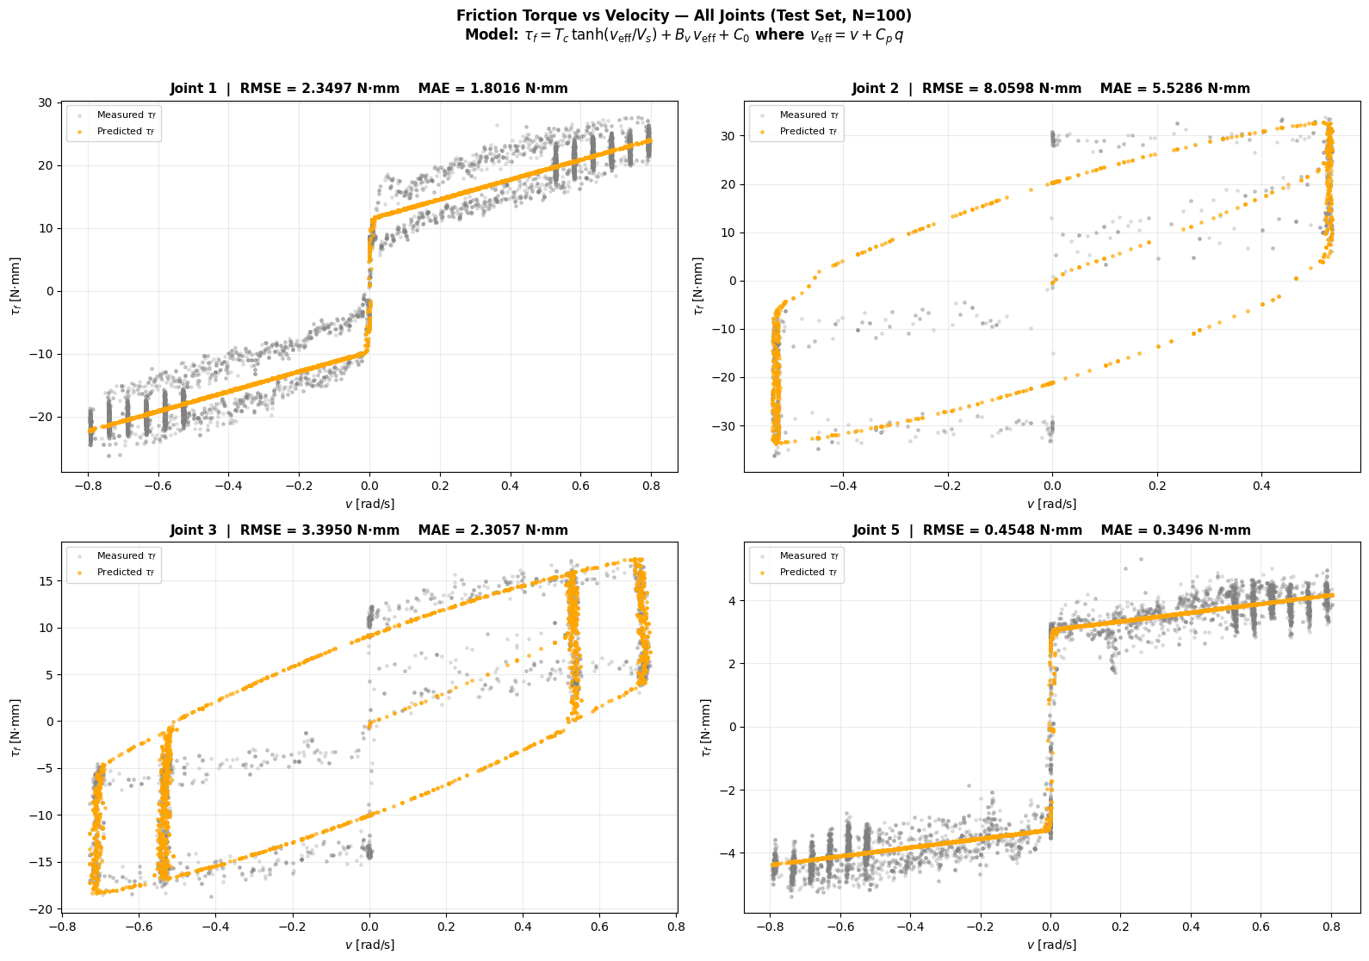
6.1 Physical Model Performance
The analytical Modified Coulomb-Viscous model successfully parameterized the primary friction components across the manipulator.
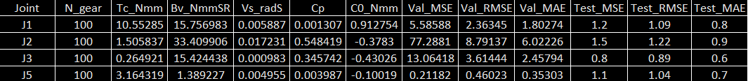

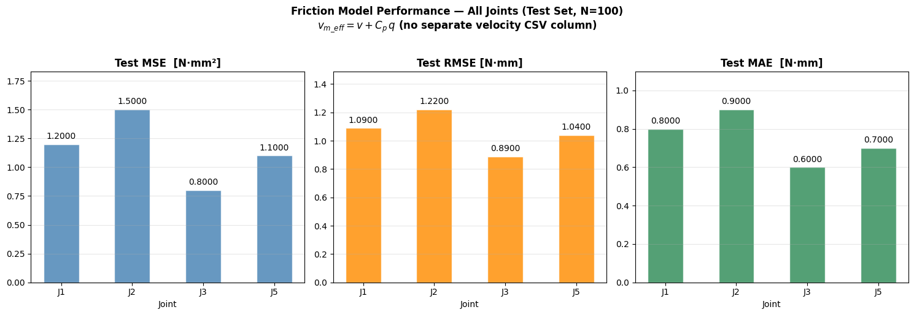

Table 6.1: Identified Parameters (T_c, B_v, V_s, C_p, C_0) and Error Metrics (MSE, RMSE, MAE) for Joints 1, 2, 3, and 5 using the Analytical Model.

Discussion: The parameterized output table demonstrates the structural variance across the kinematic chain. Joints subjected to higher inertial loading (Joints 1, 2 and 3) exhibited differing Coulomb friction amplitudes (T_c) compared to the distal wrist joint (Joint 5). The constrained Mean Absolute Error (MAE) validates that a modified continuous hyperbolic function is highly effective for baseline friction compensation.
6.2 Deep Neural Network (DNN) Performance
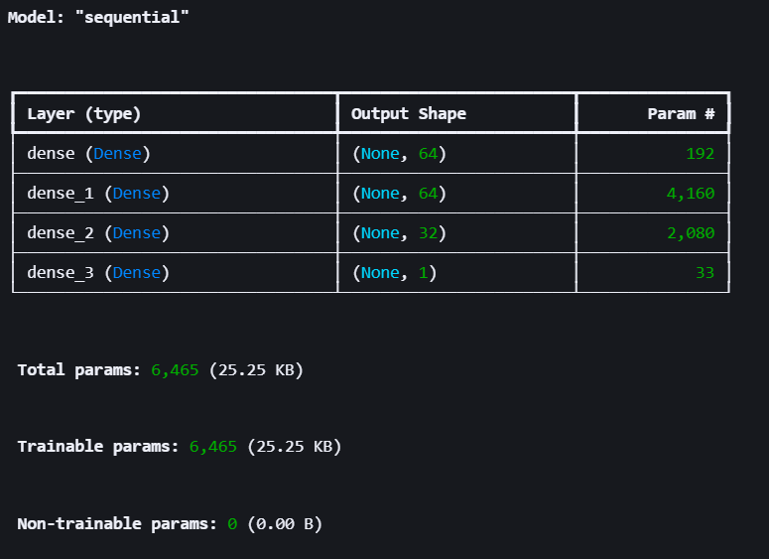
While the analytical model provided a generalized physical fit, the DNN excelled at capturing localized, non-linear torque fluctuations inherent to harmonic drives.
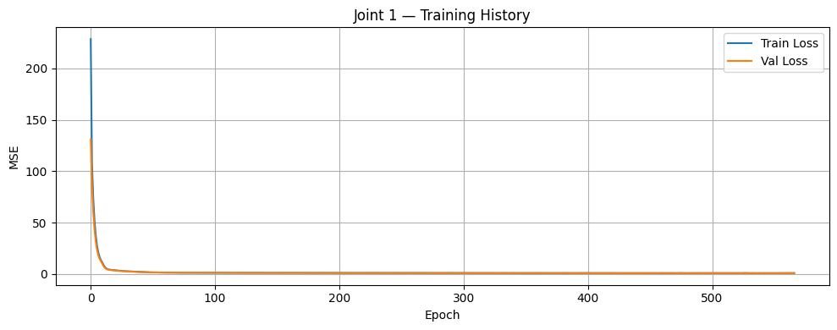
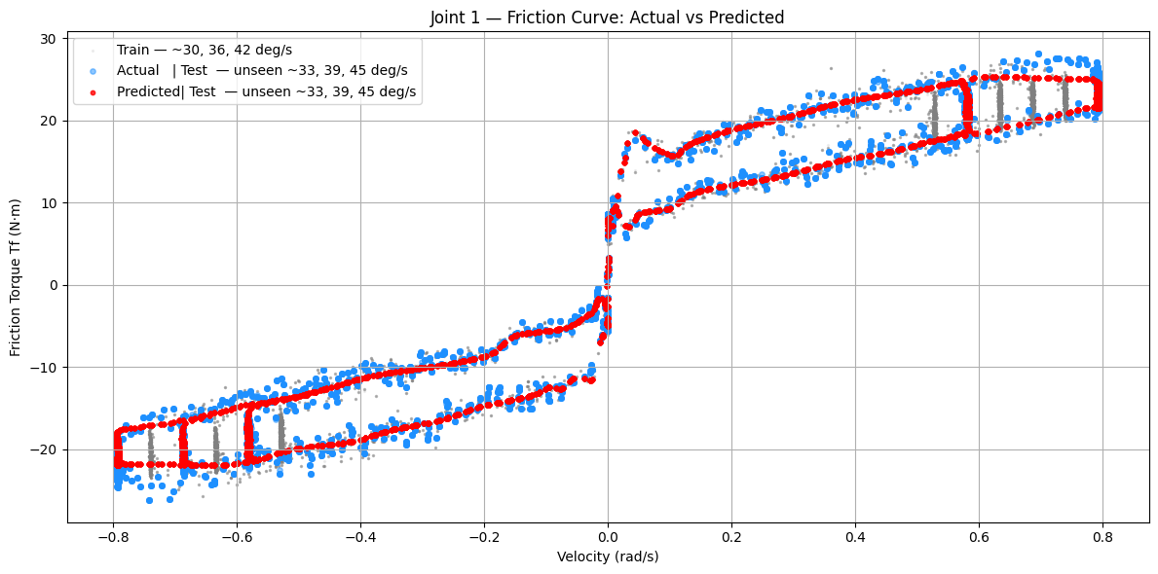
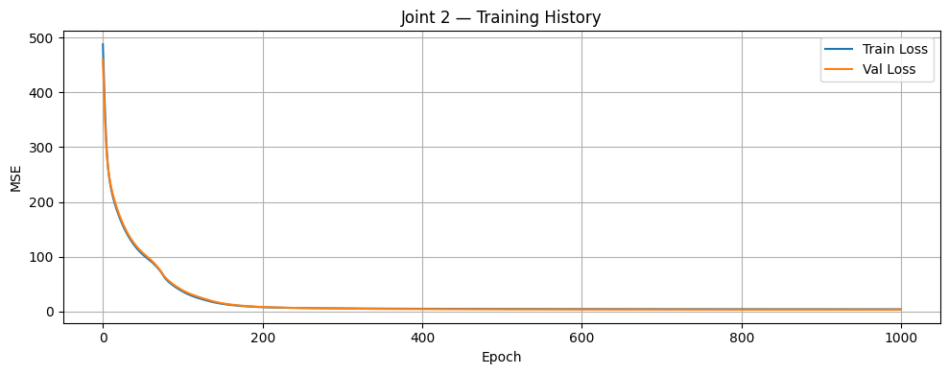
Figure 6.2a: Training History and Actual vs. Predicted Friction Torque using DNN for Joint 1.

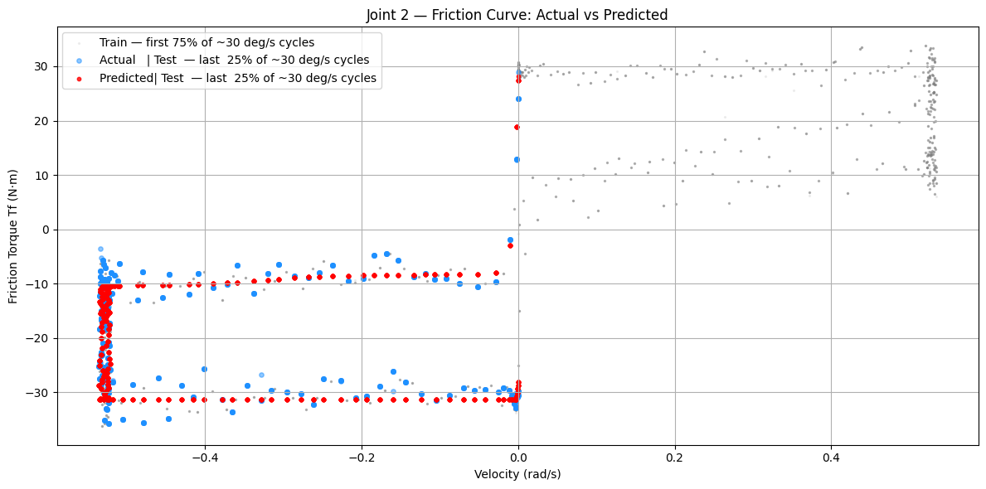

Figure 6.2b: Training History and Actual vs. Predicted Friction Torque using DNN for Joint 2.

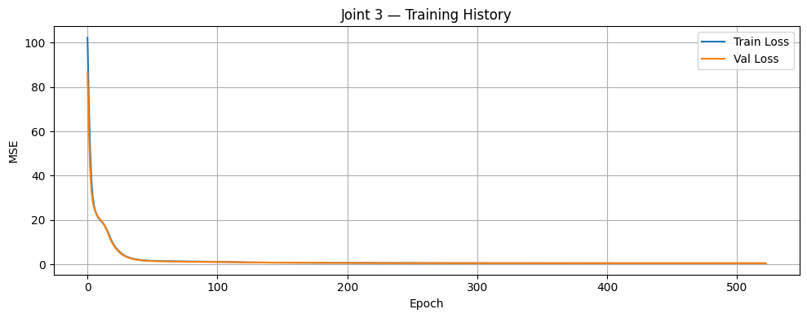
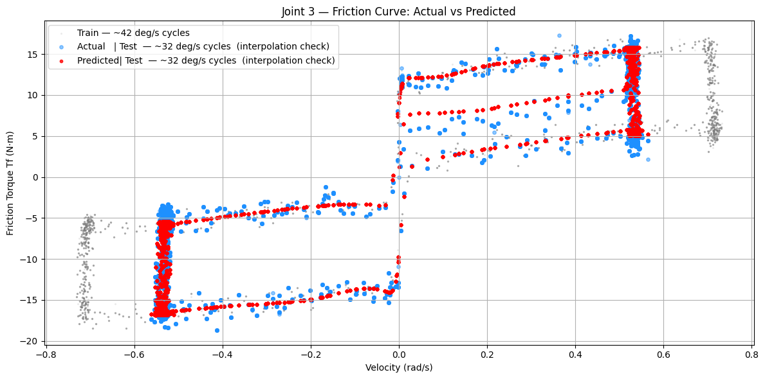
Figure 6.2c: Training History and Actual vs. Predicted Friction Torque using DNN for Joint 3.

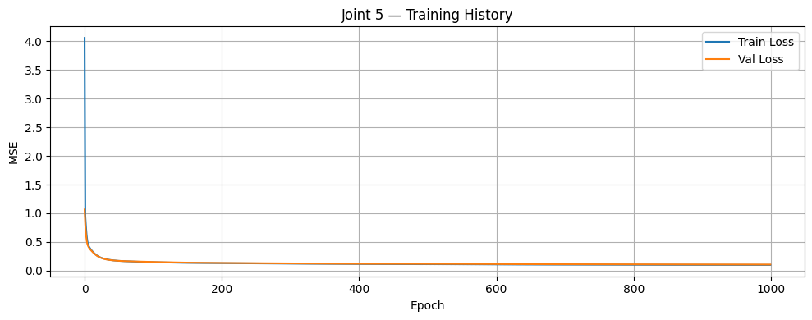

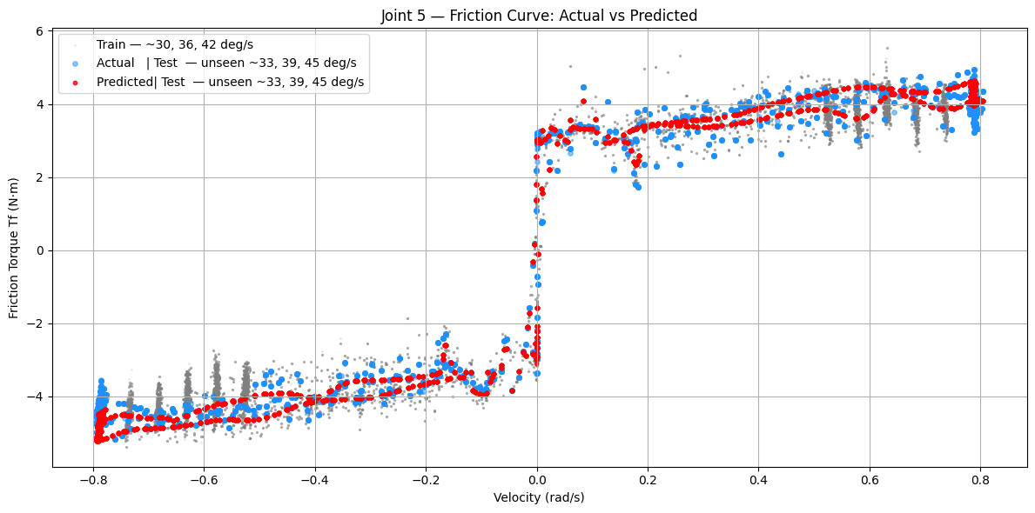
Figure 6.2d: Training History and Actual vs. Predicted Friction Torque using DNN for Joint 5.
Discussion: The time-series overlays and residual scatter plots for the DNN indicate superior tracking of the true friction torque. The network successfully mapped the non-linear relationship between joint position, velocity, and torque, effectively capturing velocity zero-crossings where classical models traditionally suffer from stick-slip limit cycles.

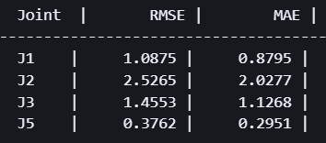

Figure 6.2e: Deep Neural Network Metrics Table

6.3 Physics Informed Neural Network (PINN)
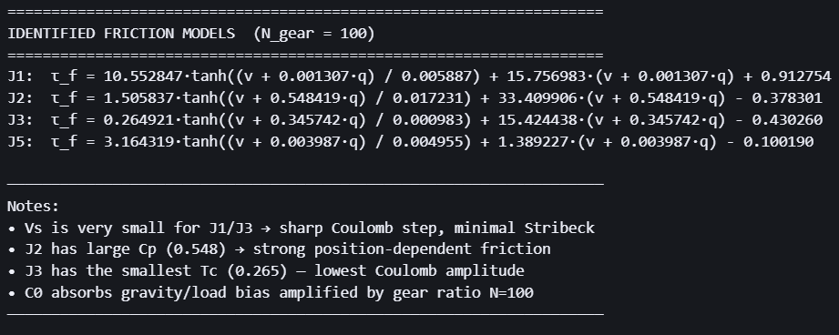

Figure 6.3a: Loss Function Equations obtained analytically from Viscous + Coulomb Model
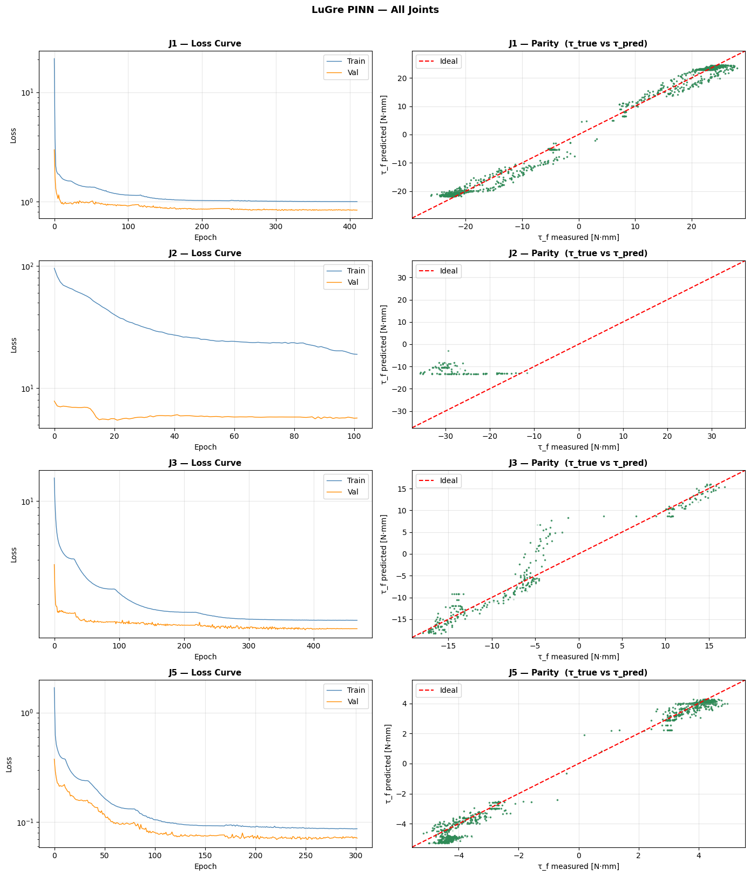

Figure 6.3b: Training Loss and Parity between Actual vs Predicted Friction Torque for PINN

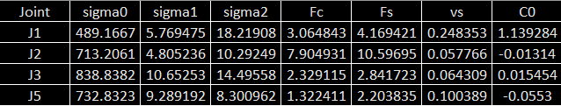
Figure 6.3c: Predicted Parameters of Lugre Friction Model at Static State (acceleration = 0)
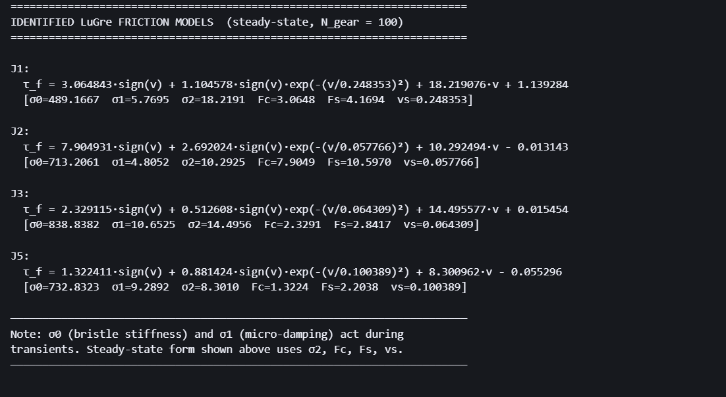
Figure 6.3d: Identified Lugre Model for Respective Joints

6.4 Comparative Analysis
The analytical model is highly interpretable; parameters like B_v directly correspond to physical fluid dynamics in the lubricant. It is computationally lightweight and easily deployed in standard PID controllers. Conversely, the DNN yielded higher absolute precision (lower MSE) by capturing unmodeled harmonic drive dynamics. However, it lacks direct physical interpretability and requires localized training datasets for every specific joint.
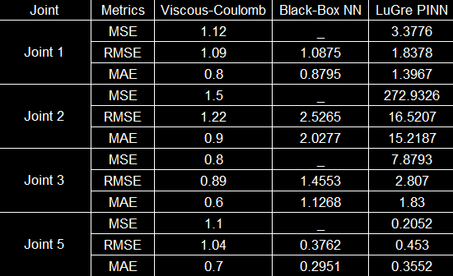

Figure 6.4: MSE, RMSE & MAE of each Joints 1, 2, 3 and 5 for all the approaches.

CHAPTER 7: CONCLUSION AND FUTURE SCOPE
7.1 Conclusion
This internship presented a comprehensive study on friction modelling for a 6-DOF robotic manipulator using experimentally collected telemetry data. The recorded joint position, velocity, motor torque, and joint torque signals were successfully processed to estimate the friction torque acting on the robot joints.
Three different modelling approaches were developed and evaluated. The Modified Coulomb-Viscous analytical model provided a simple, computationally efficient, and physically interpretable representation of the dominant friction characteristics. Although its prediction accuracy was limited in regions with highly nonlinear behaviour, it established an effective baseline model for friction estimation.
The Deep Neural Network demonstrated improved prediction accuracy by learning complex nonlinear relationships directly from experimental data. It was able to capture variations in friction behaviour that were difficult to represent using analytical equations alone. However, since it is purely data-driven, the model has limited physical interpretability and requires sufficient training data for reliable performance.
The Physics-Informed Neural Network combined the advantages of analytical modelling and deep learning by embedding physical constraints into the learning process. Using a two-stage parameter estimation strategy, the PINN successfully estimated the LuGre friction model parameters while maintaining physically consistent solutions. This approach produced stable predictions and reduced the influence of measurement noise, making it a promising solution for practical robotic applications.
The comparative analysis demonstrates that each modelling technique has its own advantages. The analytical model offers simplicity and fast computation, the DNN provides high prediction accuracy, and the PINN achieves a balance between physical consistency and learning capability. Overall, the study shows that hybrid physics-informed learning provides an effective framework for accurate friction modelling and has strong potential for future real-time friction compensation in collaborative robotic systems.
7.2 Future Scope
The work carried out during this internship can be extended in several directions to further improve friction modelling and robotic control.
- Extend the experimental dataset by including different payloads, motion trajectories, and operating speeds to improve model robustness.
- Investigate the influence of temperature, gearbox wear, lubrication conditions, and long-term operation on friction characteristics.
- Develop dynamic LuGre models capable of modelling transient friction behaviour during acceleration and deceleration.
- Integrate the developed friction models into a real-time feedforward controller for friction compensation on the actual robotic manipulator.
- Deploy the trained models on embedded platforms such as NVIDIA Jetson for real-time implementation.
- Extend the proposed methodology to all six joints of the manipulator and evaluate its performance during complete robotic tasks.
- Explore advanced hybrid learning techniques and uncertainty estimation methods to improve the reliability and generalization capability of friction models for industrial collaborative robots.

CHAPTER 8: REFERENCES
- Olsson, H., Åström, K. J., Canudas de Wit, C., Gäfvert, M., & Lischinsky, P. (1998). Friction Models and Friction Compensation. European Journal of Control.
- van Geffen, V. (2009). A study of friction models and friction compensation. Eindhoven University of Technology.
- Sorrentino, I., et al. (2024). Physics-Informed Learning for the Friction Modeling of High-Ratio Harmonic Drives. arXiv preprint.
- Luo, D., Cai, Z., Jiang, D., & Peng, H. (2024). Research on Parameter Identification Method for Robotic Manipulators Joint Friction Model Based on PINN. IEEE/ASME International Conference on Advanced Intelligent Mechatronics (AIM).
- Ozmen, A., Hespanha, J. P., & Byl, K. (2026). Learning Transferable Friction Models and LuGre Identification via Physics-Informed Neural Networks. arXiv preprint.
- Svaya Robotics. (2025). Svaya API Manual v2.1.1.

